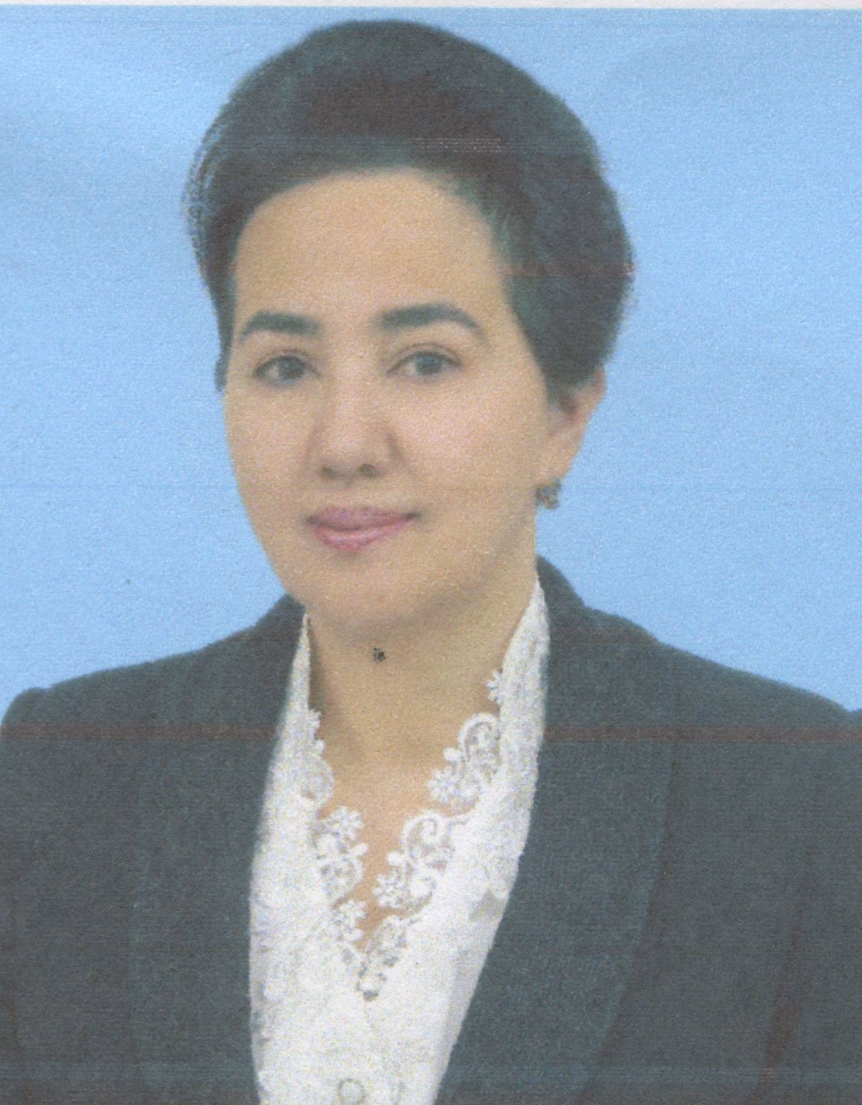
CURRICULUM VITAE
1. Family name
Aslanova
2. First names
Dilbar
3. Date of Birth
01.07.1957
4. Nationality
Uzbekistan
5. Education:
Institution  [ Date from - Date to ] | Degree(s) or Diploma(s) obtained:
Secondary School # 52, Samarkand city, Uzbekistan - 1964-1974 | High school diploma
Samarkand cooperative institute, Samarkand, Uzbekistan - 1974-1979 | University degree in Economics
Ph.D. program of the Ukrainian research-scientific institution of commerce and public catering  1989-1992 | Ph.D. degree in Economics

6. Language skills: Indicate competence on a scale of 1 to 5 (1 - basic; 5 - excellent)

Language | Reading | Speaking | Writing
Uzbek | 5 | 5 | 5
Russian | 5 | 5 | 5
English | 3 | 3 | 3
Tajik | 5 | 5 | 5

7. Work experience
2004 to the date - Vice-rector on scientific issue, Samarkand Institute of Economics and Service, Samarkand, Uzbekistan
2000 to 2004 - Head of Department of Economics and Labour sociology, Samarkand State University, Samarkand, Uzbekistan
1992 to 2000 - Head of Department of Economy and Organization of public catering, Samarkand Cooperative Institute, Samarkand, Uzbekistan
1982 to 1989 - Senior Laboratory Assistant, Department of Economy and Organization of public catering, Samarkand Cooperative Institute, Samarkand, Uzbekistan
1980 to 1982 - Senior Methodist of External Studies Department, Samarkand Cooperative Institute, Samarkand, Uzbekistan
1979 to 1980 - Economist, Samarkand branch CINOTUR, Samarkand, Uzbekistan

8. Participation in TEMPUS projects (please indicate the registration numbers of TEMPUS projects)
T012B06-2006 SM-SCM “Uzbek quality assurance system for education”

9. Present position
Vice-rector on scientific issue, Samarkand Institute of Economics and Service

10. Membership of Professional Bodies:
President of “Women Scientists” branch of Samarkand Region, Samarkand, Uzbekistan

11. Other skills:
1997 complete program of Tacis on “Improvement of Teaching Management in Samarkand” and internship in University of Coventry in England

12. Relevant publications:
Has more than 50 publications, main ones are: Economics and Socialogy of Labor, Economy Toursm, Social Economics, and Unemployment of Youth

