UNIVERSITY OF WEST ATTICA
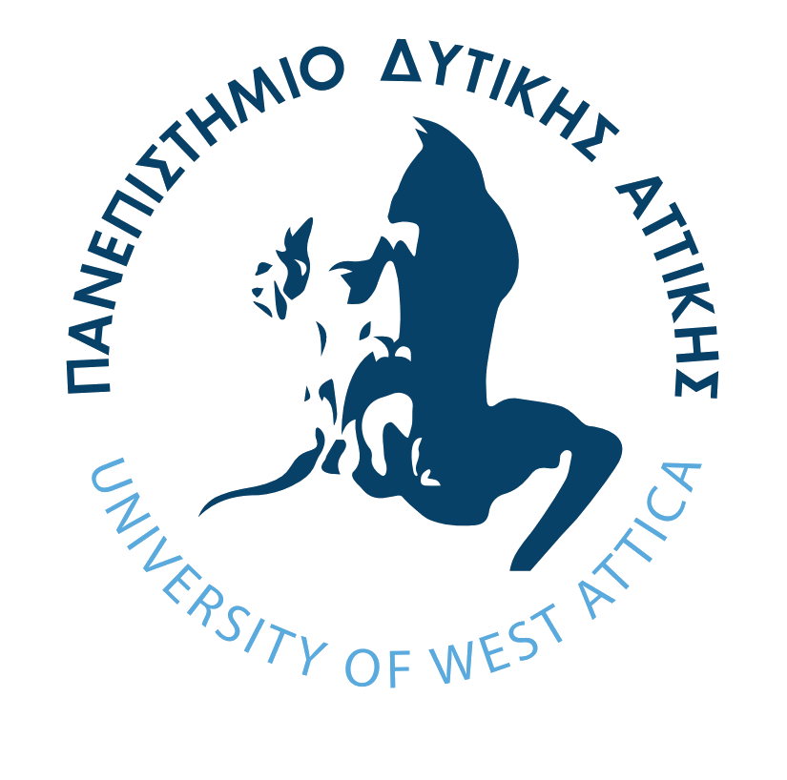PUBLIC & INTERNATIONAL RELATIONS DEPARTMENT
INTERNATIONAL OFFICE
Agiou Spyridonos Str., Aegaleo, Attica, Greece
Tel. +30 210 5385178, +30 210 5385895, Fax +30 210 5385176
E-mail euroffic@teiath.gr

ERASMUS+ CERTIFICATE OF ATTENDANCE
Name of the Host Institution

Name of the Erasmus student

Date of Arrival

Signature and Stamp
Name and status of the signatory

Date of Departure

Signature and Stamp

Name and status of the signatory
Study period | From ……………/………………../20…………
Study period | To ……………/………………../20…………
Signature and Stamp
Name and status of the signatory

University of West Attica, Pubic & International Relations Department
Agiou Spyridonos Str., p.c. 12243 Aegaleo, Attica, Greece
Tel. +30 210 5385178, +30 210 5385895, Fax +30 210 5385176, E-mail euroffic@teiath.gr

