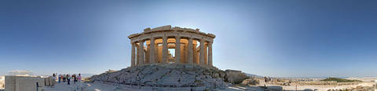
Welcome to Erasmus Student Association TEI Athens
This association has been created to ease the integration of the international students with their new life in Athens, by facilitating contacts with Greek students who have some experience on the Erasmus program and know how it feels to be in a new environment in a foreign country) through various cultural and social activities, trips, excursions and parties. Until now we provide the following services:
- Mailing list
On our mailing list you can be informed about our activities, as well as post questions, send e-mails to present yourselves or in general talk to us about anything you consider important. In order to post a message you can either go to http://groups.yahoo.com/group/esa_teiath/post or send an e-mail from your e-mail account to the following address:esa_teiath@yahoogroups.com
This is the mailing list address. If you send an e-mail in this address then all members of the list will receive your e-mail.

- Facebook
A Facebook group for the Spring Semester has been created! The name of the group is: ESA TEIATH Spring 2008 . If you wish to join in, just go to:
http://vxu.facebook.com/group.php?gid=6129767041

Buddy system
The Buddy System is a program where one or two Greek students (Buddy) are assigned to help one or two incoming Erasmus/Exchange students.
We have many Greek students that have volunteered to help us as Buddies! Most of them have recently returned from their Erasmus period abroad and they really know how you are feeling right now!!!
The job of the Buddy is to help you in the beginning of your Erasmus period. They will answer any questions you might have, they will help you solve everyday problems you may face and in general they will be the person you may contact if you need something you cannot get yourself in Athens.
Some Buddies will take their Buddy Group out for drinks, invite them to their houses, take them around the city or may even volunteer to pick them up from the airport if possible!

If you wish to participate to our buddy system or ask anything about our association, feel free to contact the ESA Tei Athens Coordinator, Dionisis Papadatos, at the email: dio.greek@yahoo.com or Alexandra Eustathiou, alex04011@gmail.com

We are looking forward to meeting and showing you around our beautiful city.

